L_SMPS600 Mains Power Supply Unit

The L_SMPS600 is an unregulated switching power supply with dual-polar output voltage.

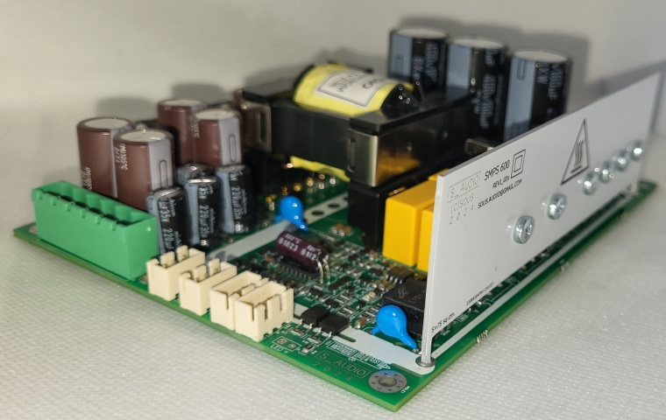
Key Features
• Unregulated dual-rail output
• Zero-voltage switching operation
• Bidirectional synchronous rectification
• High dynamic power capability
• Large primary capacitance
• Low EMI emission
• Integrated ±15 V auxiliary supply
• Optional isolated 5 V standby supply
• Remote enable via optocoupler input
• External latched fault input (DC_E)
• 1 s delayed STBY control output
• Thermal protection
• Overcurrent protection with restart
• Mains absence lockout
• Audio-trigger auto-start module (optional)

Applications

• High-power Class D audio amplifiers
• Professional audio equipment
• Active loudspeakers
• Studio amplification systems
• High-end home audio

The L_SMPS600 is a high-efficiency Class II switching power supply specifically designed for use with UcD/NCore/Purifi amplifier modules. Key characteristics include high efficiency across the entire load range, compact form factor, low weight, and very low radiated and conducted EMI.
The L_SMPS600 incorporates high-threshold overcurrent protection. Combined with large primary electrolytic buffer capacitors, this ensures high performance and guarantees high dynamic output power for the connected amplifier.
Across the entire power range, the output transistors operate in zero-voltage switching (ZVS) mode and near-zero current switching conditions. The transformer current is close to sinusoidal with minimal high-frequency harmonics, reducing EMI and improving efficiency. The absence of voltage regulation and the very low characteristic impedance of the converter improve dynamic performance.
The L_SMPS600 is equipped with an auxiliary ±15 V supply and a load control circuit directly compatible with S_AUDIO amplifier modules as well as UcD/NCore/Purifi modules.
The STBY signal is generated for the load when mains voltage is present, no overcurrent or overtemperature condition exists, and soft-start has completed. Additionally, in case of fault conditions, the power supply can be rapidly disabled via an external control signal.
Optionally, the unit can be equipped with:
Audio signal auto power-on circuitry with timer
Independent 5 V / 100 mA standby auxiliary supply

Physical Specifications

Length, without connector / with connector: 140/148mm
Width: 110mm
Height from PCB level / on 8 mm standoffs (max): 43/51mm
Weight (with connectors): 340 g

Maximum Ratings
Mains voltage: 230 V ±15%
Mains frequency: 47–63 Hz
Maximum continuous RMS output power: 350 W
Overcurrent protection threshold:
600 W version: ≥ 650 W
900 W version: ≥ 950 W
Maximum total external capacitance: 12,000 µF

Power supply efficiency and normalized output voltage depending on load

Safety precaution

The L_SMPS600 operates at hazardous mains voltage. Dangerous potentials are present on circuit elements. These components must not be touched under any circumstances.Exercise extreme caution during installation and never touch any part of the unit while connected to mains.Disconnect the unit from mains and allow at least 10 minutes for capacitors to discharge before servicing.
The unit contains no user-serviceable parts except the fuse. Replace the fuse only with the same type and rating (T5H).
This is a Class II safety device. A minimum clearance of 6 mm must be maintained between all parts of the assembly, enclosure, and wiring.
All components within the red-marked area are at hazardous voltage, including components on both the top and bottom sides of the PCB.
Use mounting standoffs at least 8 mm in height.
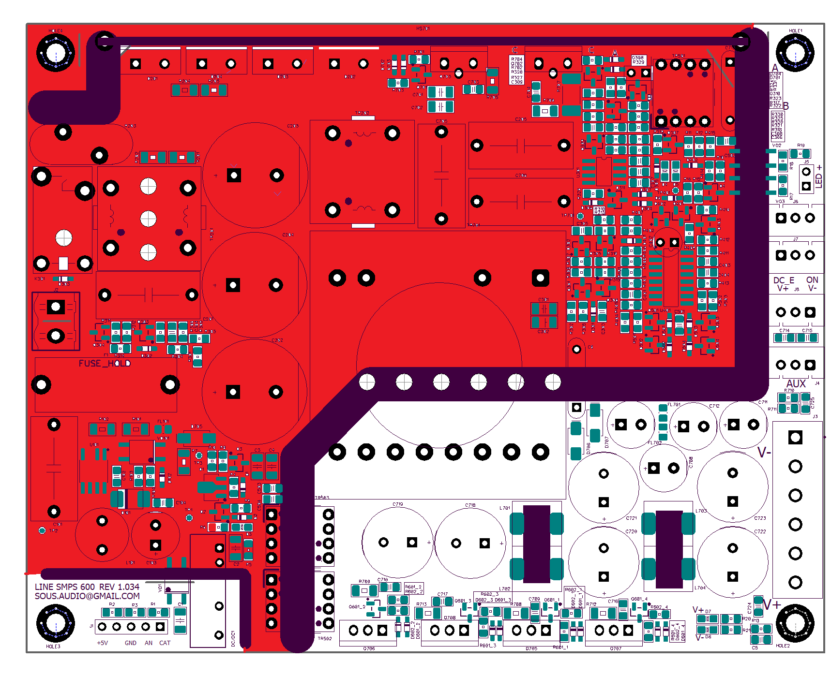
The area under dangerous voltage is highlighted in red.

Electrical Characteristics
(At 230 V mains, ambient temperature 22°C, free-standing on flat surface)

No-load power consumption: 4 W ±1.5 W
Converter switching frequency: 90 kHz ±5 kHz
Power consumption in DCE protection mode: 1.3 W
Power consumption in STBY mode: ≤ 0.8 W
Main dual output voltage:
48 V version: ±48 V ±1 V
53 V version: ±52.5 V ±1 V
57 V version: ±57 V ±1 V
Auxiliary output voltage: ±14.5 V ±1 V
Maximum PCB component temperature at 350 W RMS (30 min): 90°C
Thermal protection threshold (output transistors): 79°C ±5°C
Thermal protection hysteresis: 20°C ±5°C
Voltage drop at 200 W load: ≤ 4%

Package Contents
Power supply unit
Mains connector
Power output connector, 3-pin, 2 pcs
Installation and Setup
Installation consists of mounting the PCB to a base and connecting the required connectors.
Ensure sufficient clearance between PCB components (including discrete components) and the enclosure. Mounting standoffs must be at least 8 mm high. If this requirement is not met, installation is permitted only with an insulating spacer at least 0.5 mm thick under the PCB.
Mains input must be connected via a double-pole switch disconnecting both line and neutral conductors.
Protective earth is not required (Class II).
Output connectors are duplicated for convenient connection of two amplifiers to one power supply.

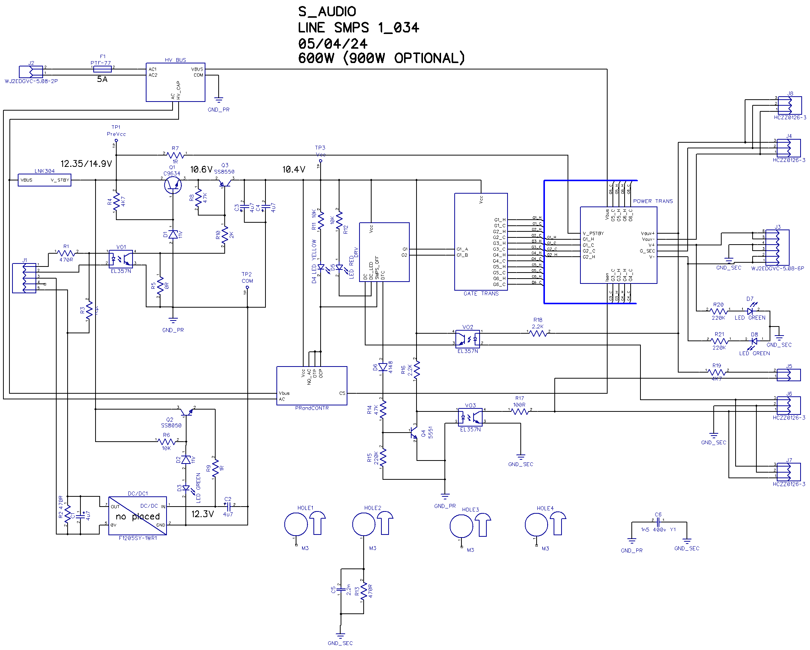
Power supply block diagram

Preparation for operation consists of installing the board on the base and connecting the necessary connectors. Please note that during installation, there must be a minimum clearance between the board components, including radio components, and the device housing. The height of the mounting posts must be at least 8 mm. If this rule is not followed, installation is only permitted if there is a special insulating gasket under the board with a thickness of at least 0.5 mm.
The mains voltage must be connected via a two-pole switch, breaking both mains conductors. Grounding is not required for safety.
For convenience of connecting two amplifiers to one power supply, the output connectors on the block are duplicated. Purpose of connector pins

Connector Description

1. Interface Connectors J6, J7
Pin 1 – STBY output
Pin 2 – GND
Pin 3 – DCE input
STBY output:Load control output, active low. Generated after soft-start completion when mains voltage is present and no fault conditions exist.
DCEinput:Fast shutdown control input, active low. Internally pulled up to AUX+ (+15 V) via 4.7 kΩ resistor.Grounding this pin disables the power supply. Red LED indicates the condition.

2. AUX Connectors J4, J8
Pin 1 – −AUX (−15 V, total 500 mA shared)
Pin 2 – GND
Pin 3 – +AUX (+15 V, total 500 mA shared)

3. Main Power Connector J3
Pins 1,2 – V− (−48 V or −53 V or -57 V)
Pins 3,4 – GND
Pins 5,6 – V+ (+48 V or +53 V or +57V)

4. LED Connector J5 (Not installed by default)
Pin 1 – Cathode
Pin 2 – Anode
The anode is connected to AUX+ via 4.7 kΩ resistor.
The cathode is pulled to ground when the PSU is operating.
When connected, the LED lights during normal operation and turns off immediately when the PSU is disabled.

5. Mains Connector J2
Pin 1 – Neutral (N)
Pin 2 – Line (L)

6. Auto-Start Module Connector J1 (Not installed by default)
Pin 1 – Optocoupler anode
Pin 2 – Optocoupler cathode
Pin 3 – Standby supply GND
Pin 4 – Reserved
Pin 5 – +5 V standby supply
The optocoupler LED input allows remote power-on when jumper R5 is removed.
The 5 V / 100 mA standby supply is galvanically isolated from other voltages.
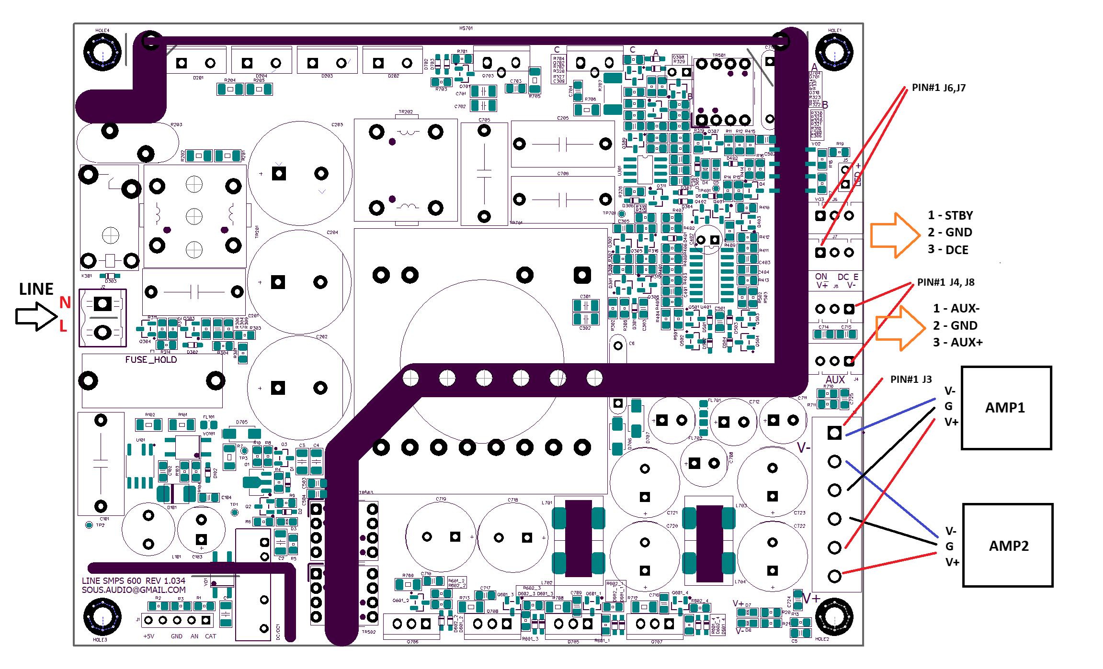
The standard power supply unit is supplied without heat sinks on the rectifier. The heating of synchronous rectifier transistors at power levels below 400W allows long-term operation of the power supply without an additional heat sink. A power of 400W RMS is equivalent to a music signal load with a peak power of at least 2x400W.

Protection Features

Output high-voltage transistor overcurrent protection with auto-restart
Overtemperature protection
Mains LINE lockout
1-second delayed STBY signal generation
External fault signal input with latch shutdown (requires mains reset)
The DC_E input is intended for connection to amplifier DC_ERROR open-collector outputs. A 15 V voltage from AUX+ is applied to DC_E via a 2.2 kΩ resistor.

When DC_E is grounded:
- Power transfer stops immediately
- STBY is disabled
- Red error LED lights
Restart requires mains disconnection
When used with S_AUDIO amplifier modules HB1_1x, HB2_06x, 3_xx, connect amplifier DCE output directly to PSU DCE input.
Main output and AUX share common ground.

Indication
Internal low-power supply indication
Output voltage presence indication (V+, V−)
Fault indication (two LEDs)
Yellow LED indicates:
No mains AC
Overtemperature
Overcurrent protection
After fault removal, the PSU performs soft-start.
Red LED indicates:
External fault signal received
Restart inhibited until mains reset

Remote Control System
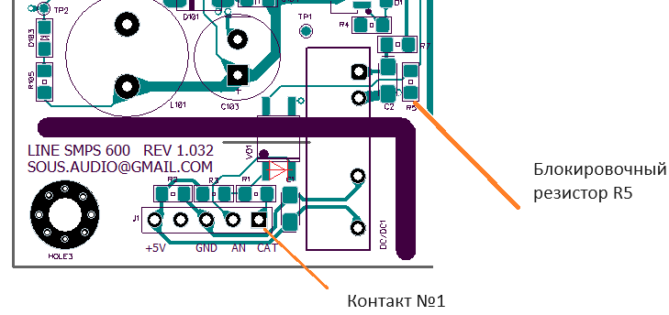
The power supply supports an external voltage start-up circuit. This function is blocked by jumper resistor R5. To activate external control, this resistor must be removed. The resistor is under dangerous voltage; removal is permitted 10 minutes after disconnecting the unit from the mains!
After activating this function, the unit will operate in standby mode when connected to a 230V mains supply, with a power consumption not exceeding 0.5W. To switch the power supply to operating mode, it is necessary to apply a control voltage from an external source to the contacts of connector J1, shown in the figure above, which transmits the start signal to the circuit via an optocoupler. Contact 1 of connector J1 is shown in the figure. See also the amplifier circuit diagram. The positive pole of the control voltage is connected to pin 1 of the connector, and the negative pole is connected to pin 2. Voltages from 3 to 6V are supported. If the control voltage is higher than 5V, a series resistor of the appropriate rating must be added, 100 ohms for each additional volt of voltage.

In some cases, the amplifier turn-on control signal has a low logic level (open collector circuit) and cannot be used to control the power supply. For this purpose, space has been reserved on the board for a common size DC/DC converter (testing was performed with the F1205S-1WR3L variant). While meeting safety requirements, this converter provides an external voltage for the control circuit. Thus, by installing this converter, you can turn on the power supply by closing contacts 2 and 3 of connector J1, after connecting contacts 5 and 1.For control voltage above 5 V, add a series resistor (100 Ω per additional volt).

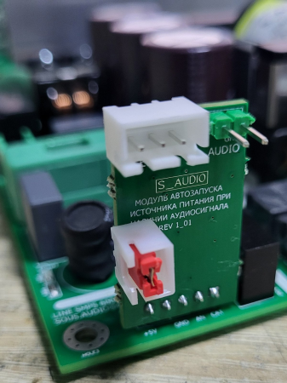
In addition, an auto-on module based on the presence of an audio signal is currently being tested. A small board is installed in the J1 connector. An audio signal is fed to the board, and a threshold circuit with a timer switches the power supply from STBY mode to operating mode for a time specified by the circuit when sound is present. It also switches the power supply to low-power STBY mode if there is no sound for more than 3 minutes.
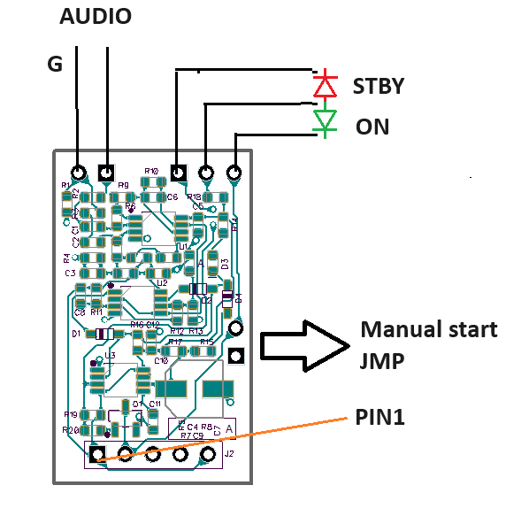
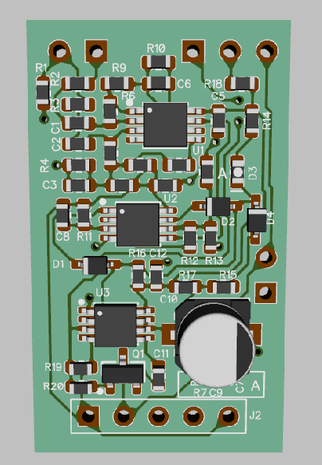
The auto-on module has connectors for audio signal input and connection of two LEDs. One of them lights up in STBY standby mode, the other when the power supply receives a command to turn on. The module also has a place for connecting a manual start button. On the component side for adjustment, there is a comparator trigger LED. When the audio level is above the threshold, this LED lights up.
The auto-on module version is designed to work with a 2V RMS source, with a trigger margin of approximately -45dB. The voltage threshold is set to 0.015V RMS.
An additional board can be installed separately by prior agreement.

Revision history:
01/05/24. Initial revision.
16/08/24 Correction of the description of connectors J6, J7 (Correction of the description of connectors, replacement of the external connections diagram and pin assignment table).

